CS 305 Project One Template

Document Revision History

Version | Date | Author | Comments
1.0 | 9/21/2024 | Nichole St.Clair

Client



Instructions
Submit this completed vulnerability assessment report. Replace the bracketed text with the relevant information. In this report, identify your security vulnerability findings and recommend the next steps to remedy the issues you have found.

- Respond to the five steps outlined below and include your findings.
- Respond using your own words. You may also include images or supporting materials. If you include them, make certain to insert them in the relevant locations in the document.
- Refer to the Project One Guidelines and Rubric for more detailed instructions about each section of the template.

Developer
Nichole St.Clair

1. Interpreting Client Needs
Determine your client’s needs and potential threats and attacks associated with the company’s application and software security requirements. Consider the following questions regarding how companies protect against external threats based on the scenario information:

- What is the value of secure communications to the company?
- Are there any international transactions that the company produces?
- Are there governmental restrictions on secure communications to consider?
- What external threats might be present now and in the immediate future?
- What modernization requirements must be considered, such as the role of open-source libraries and evolving web application technologies?

Artemis Financial specializes in creating comprehensive financial plans for individuals, covering areas like savings, retirement, investments, and insurance. Given that the company manages sensitive client information, such as Social Security numbers and tax data, secure communication is crucial. Although there’s no indication that Artemis Financial operates solely in the US, it’s reasonable to assume the company engages in international transactions. One key regulatory concern for secure communications is safeguarding trade secrets from potential exposure. Due to the critical need to protect all forms of information, a primary external threat involves unauthorized access to client data, necessitating strong encryption measures to secure it from outside parties. Additionally, Artemis Financial should prioritize regular maintenance checks to address bug fixes and identify vulnerabilities in their security protocols.

2. Areas of Security
Refer to the vulnerability assessment process flow diagram. Identify which areas of security apply to Artemis Financial’s software application. Justify your reasoning for why each area is relevant to the software application.

- Input Validation: Artemis Financial mandates input validation to confirm the identity of information owners, enhancing user protection. This validation will be implemented as string checks.

- Code Quality: Within code quality, access controls can be established to restrict users to their own information, preventing unauthorized access to others’ data or the server.

- APIs: Developing an API is essential for both internal and external operations, allowing control over which data can be accessed.

- Code Error: Implementing error handling helps identify areas in the API that require fixes, ensuring user information remains secure and inaccessible.

- Cryptography: Employing cryptography at Artemis Financial is vital to protect user information from being compromised globally, especially when dealing with multiple currencies.

3. Manual Review
Continue working through the vulnerability assessment process flow diagram. Identify all vulnerabilities in the code base by manually inspecting the code.

After reviewing the code and conducting a Vulnerability Assessment, I analyzed both the POM.XML and the Greeting Controller. In the XML file, I sought to verify the presence of an Apache Validator. In the Greeting Controller, I observed a lack of input validation, which I noted for future improvement. While the code quality was generally acceptable, it had significant issues with error handling, as it was absent. Regarding the API, I found several deficiencies, including a potential breach due to user input not being submitted via a POST method. Lastly, I attempted to check for signs of cryptography but was unable to locate any.

4. Static Testing
Run a dependency check on Artemis Financial’s software application to identify all security vulnerabilities in the code. Record the output from the dependency-check report. Include the following items:

- The names or vulnerability codes of the known vulnerabilities
- A brief description and recommended solutions provided by the dependency-check report
- Any attribution that documents how this vulnerability has been identified or documented previously
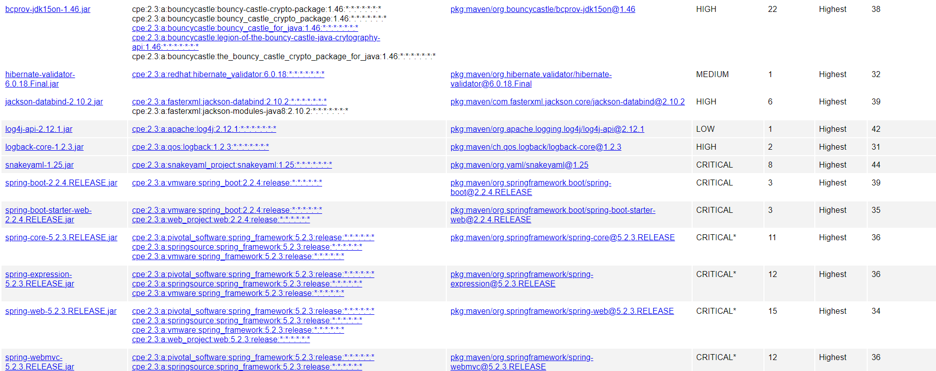

5. Mitigation Plan
Interpret the results from the manual review and static testing report. Then identify the steps to mitigate the identified security vulnerabilities for Artemis Financial’s software application.

The swift solution for the identified security vulnerabilities at Artemis Financial is to update to the latest versions of Snakeyaml, Hibernate Validator, Apache Tomcat, and BouncyCastle.

